Georgia State Parks and Historic Sites
Weekend Summary
05.04.2020

Crowds:
- This weekend proved to be the busiest weekend since the pandemic started. Sites that had to close the park to day use traffic due to capacity for one or both days included: Black Rock, Cloudland Canyon, Don Carter, Fort Mountain, Ft. Yargo, High Falls, James H. Floyd, Mistletoe, Providence Canyon, Red Top Mountain, Rocky Mountain, Sweetwater Creek, Tallulah Gorge, Vogel. Wormsloe had restricted access both days.
- Mistletoe State Park had to adjust their modified day-use capacity plan on 5/3 due to LED having to break up three large groups for social distancing violations throughout the past two weekends. AH Stephens State Park had heavy equestrian usage.
- Golf Course activity
  - All the courses had heavy weekend use, up 40% over last year. The Creek Golf Course at Hard Labor Creek State Park experienced heavy visitation over the weekend and a full tee sheet on Sunday. Arrowhead Point Golf Course at Richard B. Russell State Park saw significant play through cabin rental golf packages and day-use golfers.

- Boat ramp activity
  - The boat ramps reached capacity at Ft. McAllister and Florence Marina both days.
  - Richard B. Russell, Elijah Clark, and Mistletoe State Parks experienced busier boating visitation than previous weekends.
  - Boat ramp parking overflowed into the day use parking area at Crooked River on Saturday - this is their standard protocol when overflow occurs.

Staffing issues:
- As of today, the Division has 111 part-time and full-time staff out due to COVID-19 related reasons. A total of 40 Camp Host Units (approximately 80 people) have left due to COVID-19 and 33 units have been replaced.

Positives
- Most sites are experiencing revenue increases with overnight facilities, park pass, and golfing.
- Mistletoe State Park earned more park pass revenue this weekend than last year’s July 4th holiday, despite the temporary day use closure on 5/3.
- LED presence was heavy at several of the parks and was much appreciated.
- Utilizing staff from other sites and region staff to assist busier sites is helping with staffing issues.
- The dedication and teamwork exhibited by most of our staff has continued. Several sites have made impressive contributions to the E-Ranger videos.
- Reynolds Mansion has been selling takeout lunches to island residents and workers using food previously purchased for groups that have canceled their reservations, earning over $3,700 thus far.
- The bait shop at Crooked River exceeded revenue compared to last April.
- Website and social media for 4/27/20 - 5/3/20:
  - eRanger Video Series:
    - webpage views- 540
    - YouTube Views- 1133
    - Facebook reach - 112,300 this week. YTD-726500
  - Alerts Page: 34,370 pageviews
  - Reservations pageviews were up 112% YoY
  - Total pageviews - up 151% YoY- 2 mil views this week
  - 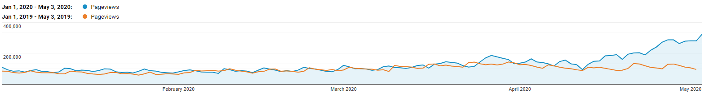

Challenges
- Sweetwater Creek State Park staff continues to report encountering irate guests due to day-use capacity limits. Operational adjustments have been made to mitigate these interactions, but they are still occurring. LED continues to deal with vehicle related issues on Mount Vernon Road and at the park due to the day-use capacity closures. There was one report of a woman parking her car on the road to ask about the closure causing a potential traffic accident. On 5/2, LED responded to a discharged firearm call on the yellow trail bridge area of the park. Sweetwater Creek State Park reported LED had to break up a large group of over 10 on 5/2.
- Fort Yargo State Park reported encountering some irate guests due to the day-use being closed. LED was notified about a couple of vehicles that tried to circumvent the closures at the entrance areas causing potential safety issues. Fort Yargo also reported people stealing toilet paper and soap from the comfort stations over the weekend.
- Red Top staff reported guests were moving barrels to park and some folks complained about the beach regulations of no chairs and umbrellas.
- Watson Mill Bridge State Park staff reported speaking with two large groups of motorcycle riders.
- On 5/2, Elijah Clark State Park had one group of over 10 the staff had to break up at a campsite.
- Although sites are effectively using staff sharing, there are still staffing shortages due to COVID concerns.
- Water access points such as the boat dock at George L. Smith and the springs area at Magnolia Springs have experienced crowding and some rule violations.
- Some cleaning and disinfecting supplies are still on back-order.
- Fort King George experienced high day use and guest compliance issues.
- LED dealt with several ATVs on the horse trails at General Coffee. Several power tools were stolen at General Coffee - law enforcement is involved.
- Some visitors continue to access playgrounds despite barricades and signs.
- Seminole State Park had social distancing issues on the beach, as well as, LED assisted in a verbal altercation between two groups resulting in one group being told to leave the park for the day on Saturday.
- A local resident is angry about the number of visitors at Providence Canyon and the traffic issues.
Weekend Occupancy:
Past Weekend:
Our overall occupancy for all reservables increased 7% this past weekend. This is the first time since COVID started that the overall weekend occupancy has increased. Last weekend we saw a 4% drop in occupancy. Cottage rentals continue to return, as we were at 76% occupancy this past weekend. Last weekend, cottage occupancy was at 63%. Camping continues to see high occupancy, reaching 89% this past weekend. This is up 13% from the same weekend last year. And almost all of yurts were occupied as we reached 97% occupancy.
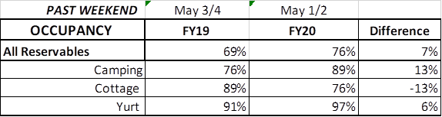
Upcoming Weekend:
If we look at the upcoming weekend, we are already seeing a 20% increase in all reservables. Camping is already showing a 29% increase over last year! Cottages are only showing a 13% decrease. Last weekend at this point we were showing 42% decrease. For this upcoming weekend, yurts are already 97% booked. This is up 16% over last year.
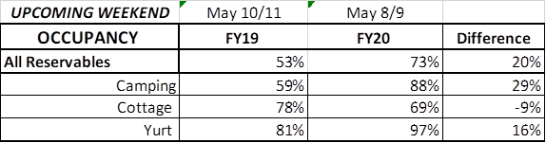
Revenue:
For the month of March through May 3rd, we have seen a decrease in revenue of 21% or a loss of $1.5 Million. This past week, April 27th – May 3rd, we actually saw a 48% or $408,000 increase in overall revenue. This is the third week our revenue has increased since the COVID situation began. Last week we saw a 22% increase.
ParkPass has decreased 11% or $89,000 during this timeframe. This past week is the first time we have seen an increase (11%) in ParkPass. ParkPass revenue is starting to bounce back as we have resumed Kiosk operations this past weekend.
For overnight accommodations – camping revenue has now increased 30% or $704,000. This past weekend it increased 145% or $350,000. This is the 3rd week in a row the revenue has more than doubled. Cottages also saw a significant increase this past weekend, and are now only at a 32% or $540,000 loss during this time period; yurts are at a 10% loss, 4th straight week that yurts have increased revenue, jumping up 171% this past week.
Golf continues to see a substantial improvement over last year, having a 40% increase this past week. This large increase contributed to golf’s revenue increasing 9% or $34,000 during this entire time period.
Historic site admissions continue to drop, decreasing 94% this past week. From March thru May 3rd, admissions are down 74% or $389,000.
Retail is now at a 59% decrease since March or a $634,000 loss. It dropped 73% this past week.
We are seeing the revenue significantly improve over last week due to several reasons:
- In early April we changed policy from collecting only a one-night deposit when booking a reservation, to collecting all revenue at the time of booking. This is the reason for the significant increase to camping revenue, and slowing the bleeding resulting from lower cottage occupancy. This will have an effect on future revenue collections.
- Camping occupancy has improved over the previous year for the 3rd weekend in a row.
- And again, the number of cancellations is starting to significantly slow down. Although we do need to keep in mind, that for future refunds, we will be refunding the revenue for the entire stay, rather than just a one-night deposit.

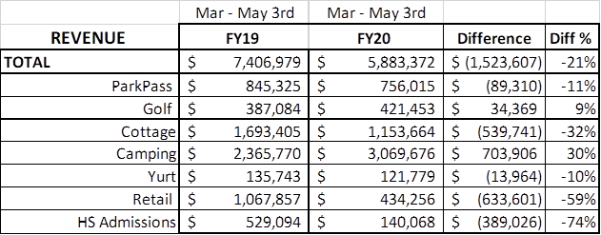
Cancellations/Refunds:
Through this Monday May 4th, we have had 23,300 cancellations, including $2.0 Million in actual refunds and a loss of future revenue of $7,825,000.
This is 1,600 more than last Monday, when we were at 21,700 cancellations. The significant drop in the number of cancellations continues, as initially we had 4,000 – 5,000 a week and now we are down to approximately 1,600 the past 2 weeks. Last year during the same week we had 1,000 cancellations, so customers are still continuing to cancel reservations at a higher rate than previous years.
Last year during the March thru YTD, we had 6,500 cancellations, including $324,000 in actual refunds and a loss of future revenue of $1.5 Million.
So, total cancellations have increased over 16,800 or 358% and the amount of refunds have increased $1.7 Million.

